***PAAREES PERFUMES***

***VERSACE***

***FOR MEN***

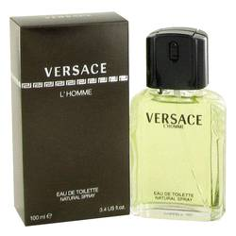

# 

***VERSACE L’HOMME***

## *Description:*

Versace L'homme by Versace Cologne. Versace L'homme is a classic fragrance that gets noticed. This spicy woody scent is ideal for the office or a night on the town, and its lasting scent carries you through the day and into the evening. Fragrant notes of petit grain, basil and pimento create an intriguing aroma that awakens the senses, and a splash of lemon, cinnamon and pimento completes this unforgettable scent. This timeless men's fragrance was launched by Versace in 1986.